Above list the conversation with images with the goDaddy Team.

Helpful video : <https://www.youtube.com/watch?v=MVBAnucCwrg&ab_channel=CodeWithNate>

Step (1) Adding route 53 CNAME for HTTPS certificate

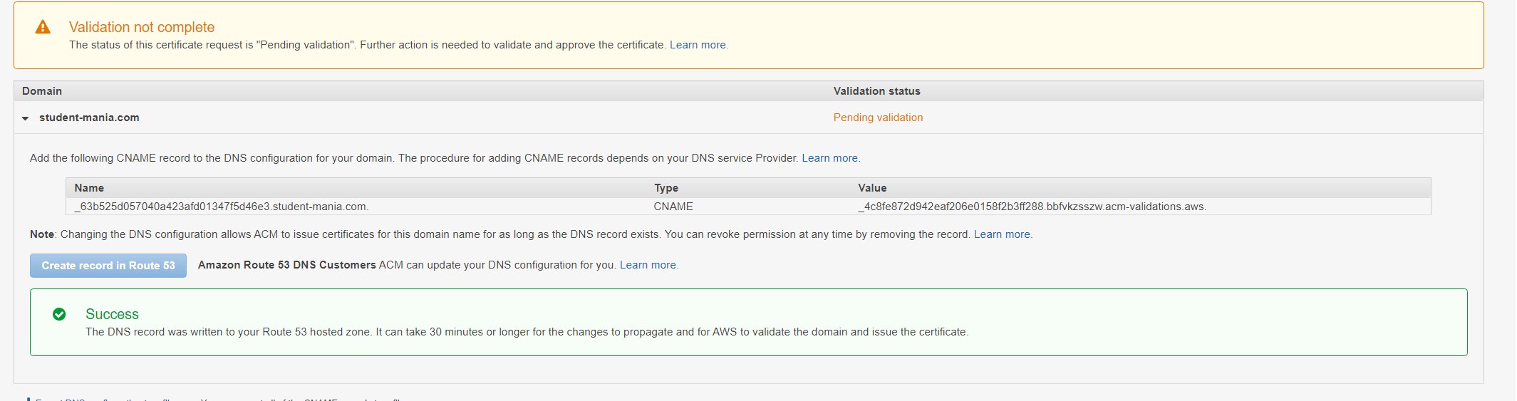

Step (2)

Ass you can see we added to route and now it is saying it can take up to 30 minutes for the change to propagate and for aws to validate the domain we have setup



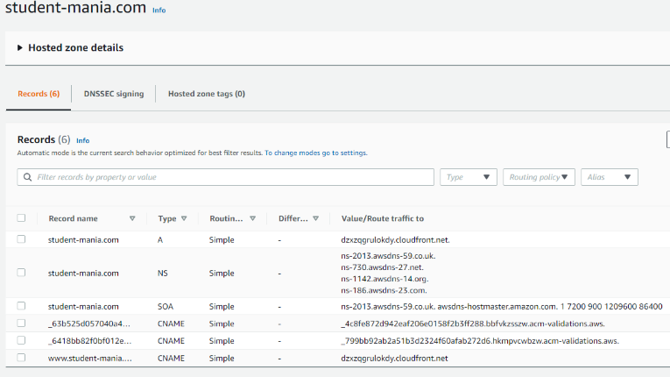 (2.1) after some time you can see it had been added

Step (3)

After this I went and checked what listeners I had on the load balancer. By default you can see that you have HTTP: on port 80 . As you can see below.

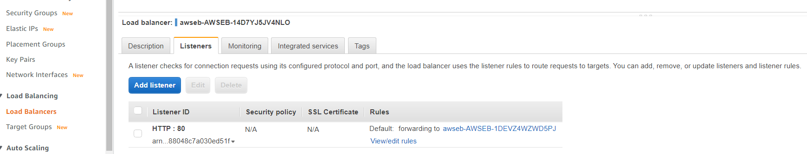

Step(5)

But we want to change it to HTTPS listener on port 443. As we don’t want unsupported traffic running to our servers

But first must check if it was issued yet , and as u can see it was

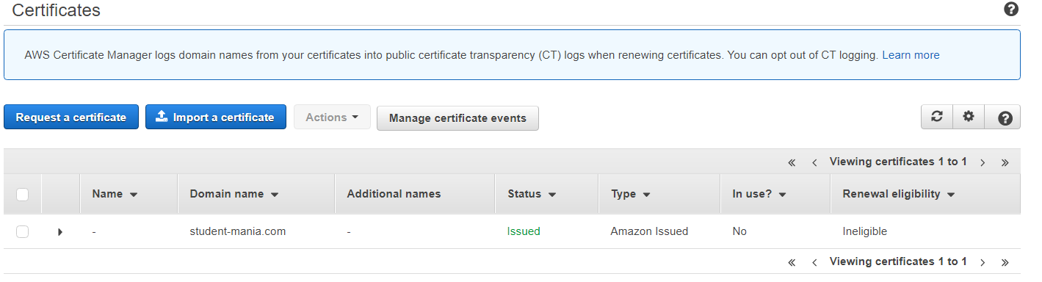

Step (6)

Change the http to Https: as seen below

From:

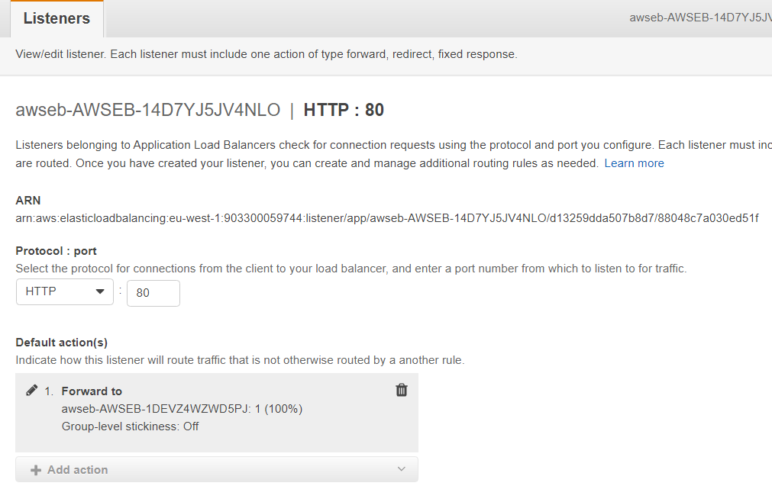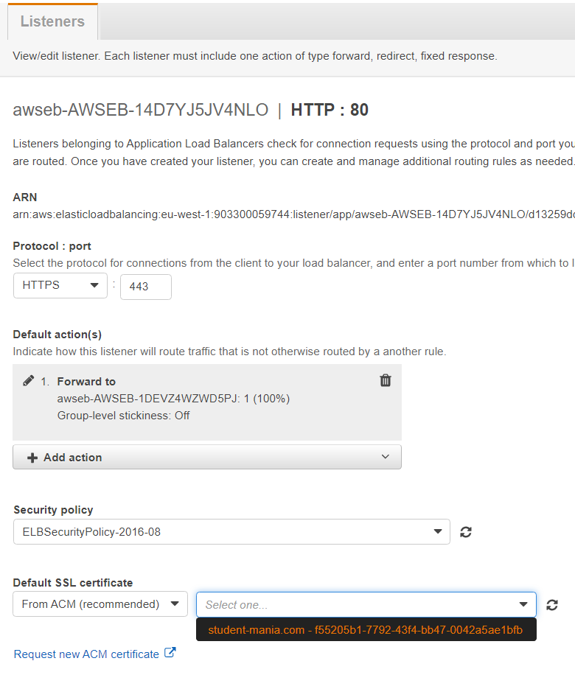

To: as you can see when the certificate is issued you will then be able to select the https as a listener at the bottom of the new 443 port.

* *This which will only appear when you have the CNAME added to the Route53 and certificate issued!*

Step (7)

When you click “update” you will get the following response to confirm your changes.



Step(8)

Was issued a warning after this update which told me that the port *was not* receiving traffic!.

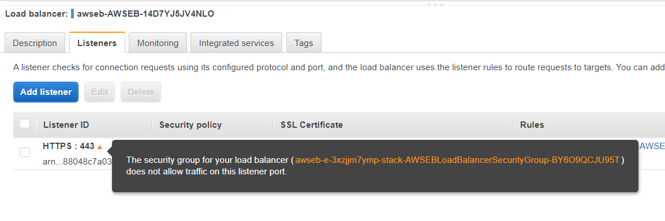

Step (9)

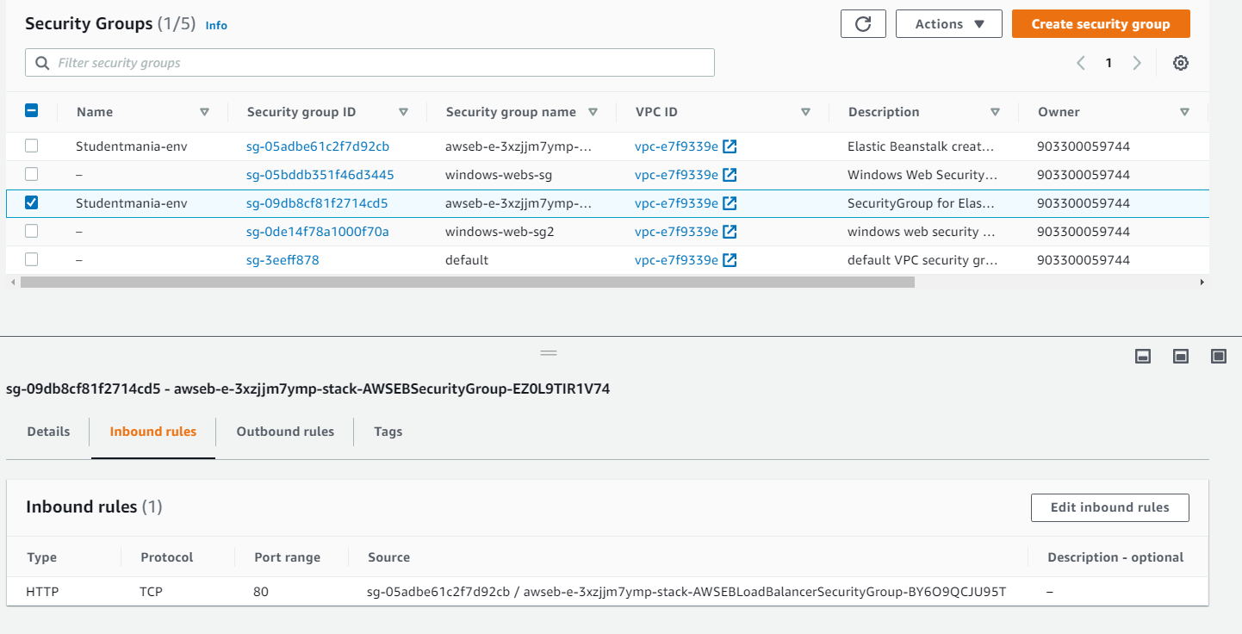This which I had to check in the security group to see what ports it was using for access.

As you can see only port 80 was listed at the bottom of the image!.

Step (10)

Changed inbound rules as seen below!

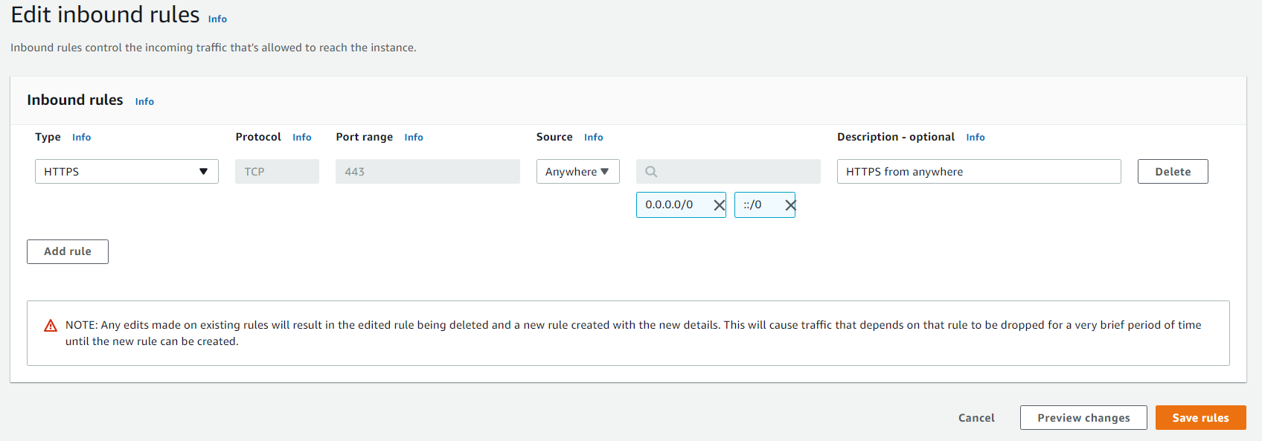

Step ( 11 )

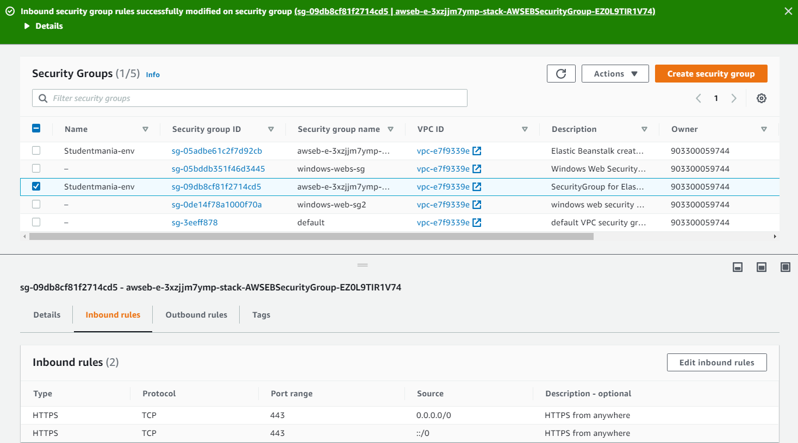Confirmation of change and should work for website now (fixed our HTTPS Issue)

NOW just to fix the following issue we have left with our database

